2.3 I can select and use appropriate editing and formatting techniques to aid both clarity and navigation

When creating my website I wanted to create a streamlined look with a clear simple font and simple images. One of the images I used on my website was taken by me on my mobile phone. I sent this email to myself and copied and pasted the image into Microsoft Word to crop and resize the image. Clicking on the image adds a picture tools formatting option to the ribbon in Word as below;

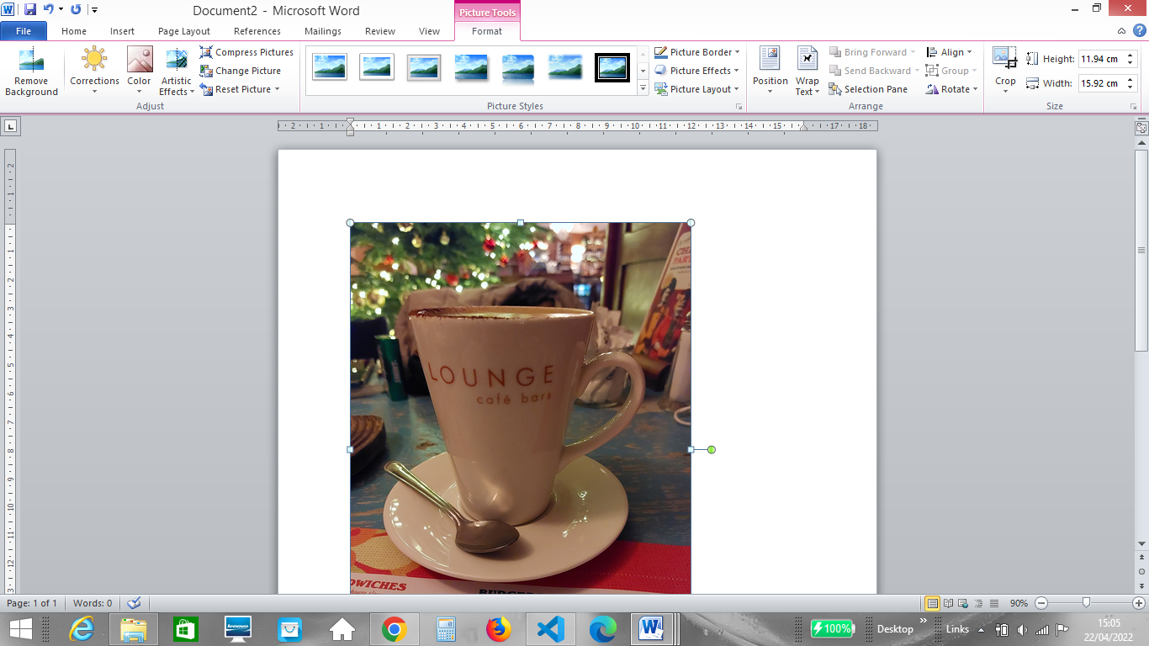

There are numerous options online for me to choose from if I need more complex image formatting software options for my images, with the most popular being Gimp. As I did not require any special effects I was happy to use the picture editing tools in word to edit my image. As the image is simple with no special effects and of a low resolution it will ensure that my website is quicker to load.

I added a navigation tool bar to my website so that users could navigate the website easily. The below image shows the navigation bar and the simple image, text and layout used;

